**Assignment-2 Course Code: PHY 2105 Spring: 2024**

**Last Date of Submission: 08/05/2024**

Course Title: Physics Content: Coulomb’s Law +Electric Field +Electric Potential

1. Two equally charged particles are held 3.2×10-3 m apart and then released from rest. The initial acceleration of the first particle is observed to be 7.0 m/s2 and that of the second to be 9.0 m/s2. If the mass of the first particle is 6.3×10-7 kg, what are (i) the mass of the second particle and (ii) the magnitude of the charge of each particle?
2. Four charges +2q, +4q, +2q and –2q are placed at the corners of a square. (i) Draw the arrangement of the charges. (ii) Calculate the magnitude and direction of electrostatic forces on a charge -1q at the intersection of the diagonals of the square of side 10 cm if q = 3×10−9C.
3. From the figure, (i) Calculate the magnitude of net force on test charge q0. (ii) Calculate the direction of net force on test charge q0. 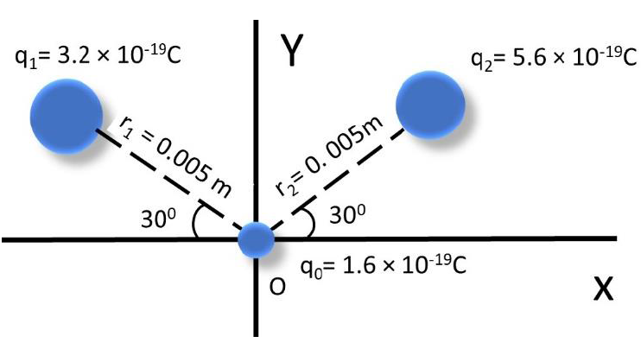
4. Two equal charges of 10×10-5 C are shown in fig below; each produces an electrostatic force at point *P* on y axis. (i) What is the magnitude of the force at *P*? (ii) What is the direction of Coulomb’s force?

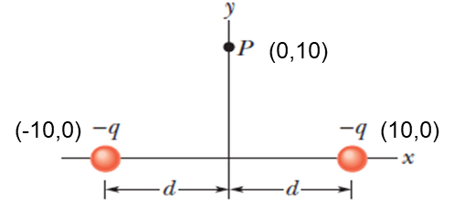

+*q*

1. Four charges +2q, +4q, +2q and –2q are placed at the corners of a square. (i) Draw the arrangement of the charges. (ii) Calculate the magnitude and direction of electric field at the intersection of the diagonals of the square of side 10 cm if q =57×10−9C.
2. A charge of -1.0 μC is located at the coordinates (0,2) while a second charge of +1.0 μC is located at the coordinates (1,0). Draw the charge arrangement and determine the value of the following quantities at the origin: (i) the magnitude of the electric field E, (ii) the direction of the electric field.
3. Two charges 10×10−9 C and 20×10−9C are placed at the two corners of a base of an isosceles right angle triangle. The length of the arms is 0.03 m. Calculate the net electric field and direction at the third corner of the triangle.
4. An electric dipole consists of charge + 2e and -2e separated by 0.75nm. It is in an electric field of strength 5.4×10-8 N/C. (i) Calculate the magnitude of the torque on the dipole when the dipole moment is (a) parallel to and (b) perpendicular to the electric field. (ii) How much work is required to turn an electric dipole 1800 in a uniform electric field of magnitude E = 5.4×10-8 N/C if the dipole moment has the initial angle 650.
5. Water (H2O) is a molecule that has a permanent dipole moment is 6.2 x 10**- 30** C m. What is the dipole distance of water molecule? If the molecule is placed in an electric field of 1.5 $×{10}^{4}$ N/C, what maximum torque can the field exert on it?
6. Calculate the electric potential at a point P, located at the centre of the square of point charges

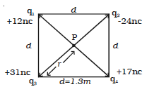

shown in the figure.

1. In Fig. below, what is the net electric potential at point P due to the four charge particles if V = 0 at infinity, q = 5.00 fC, and d =4.00 cm?

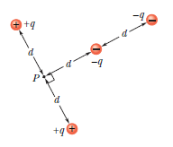

1. The three particles are fixed in place and have charges *q*1= *q*2= +*e* and *q*3=+2*e*. Distance *a=* 6.00 µm. What is the magnitude of the net electric potential at point *P* due to the particles?

